Transcript of Functionality

Programmers:

Adam Schroeder

Mack Baker

Brandon Huynh

Current release hash: b807cbb

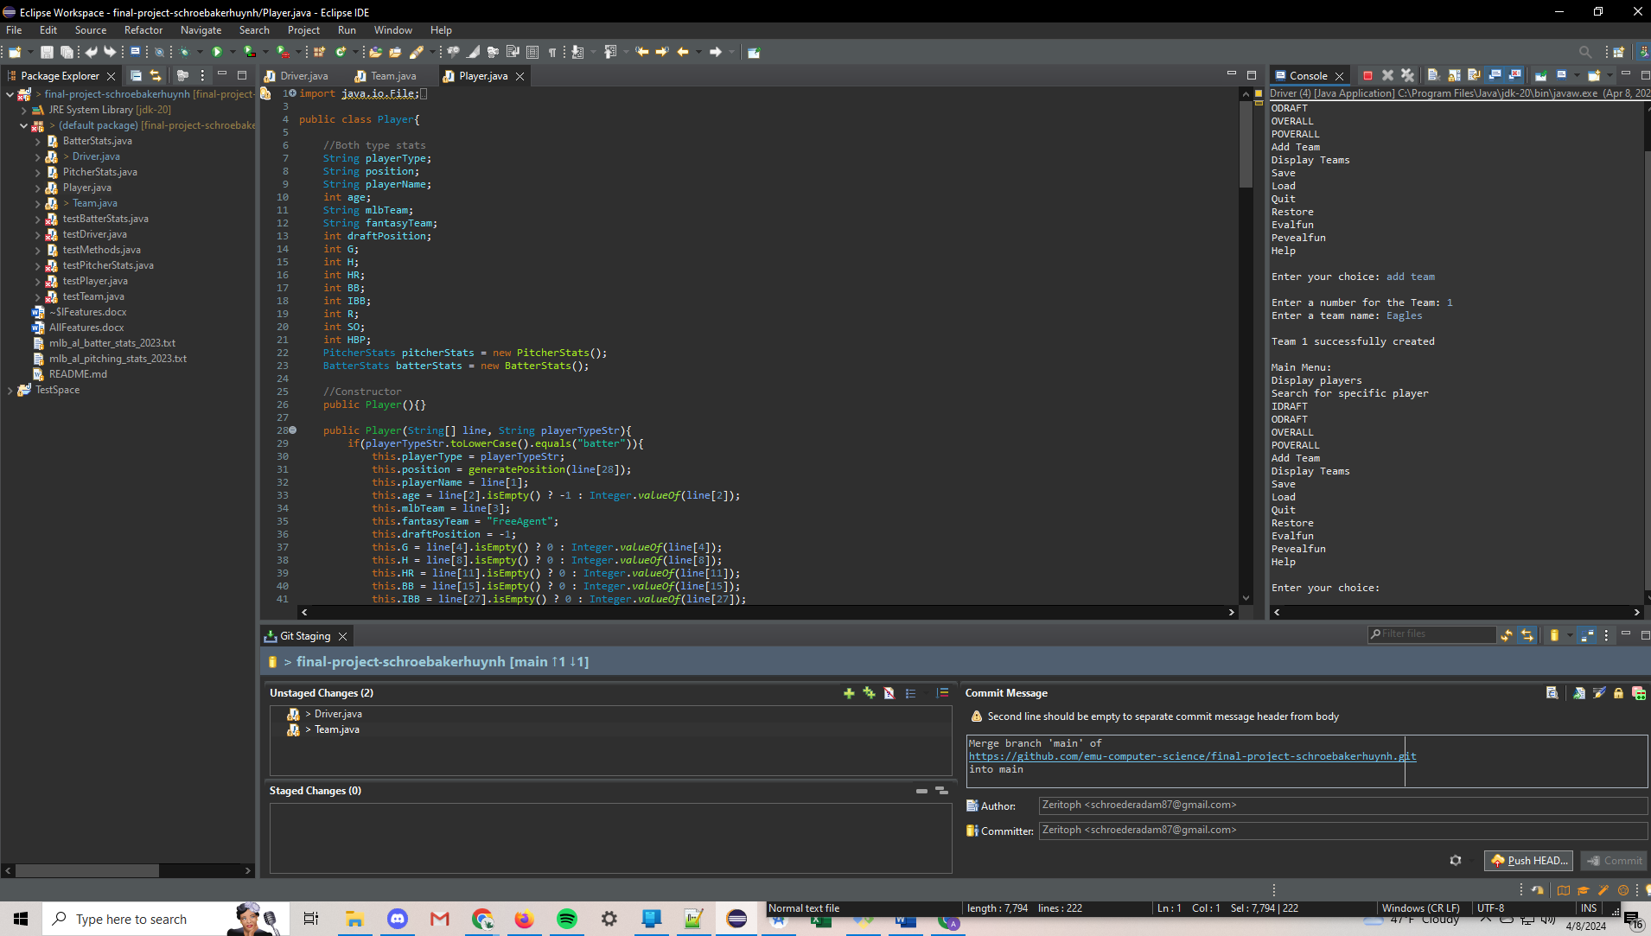

Current functionality includes:

* Ability to offer text input instead of number based
* Reading in full roster of players available for fantasy draft
* Creation and management of Fantasy Team
* Categorization of player stats, divided between Pitcher and Batter stats
* Ability to display current roster of fantasy team
* iDraft
* oDraft
* Overall
* Poverall
* Player search

Burndown Chart Status:

